CURRICULLAM -VITAE
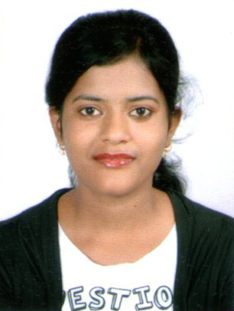

NAME: SUBHASMITA JENA
Mobile: 7353739709/7019648979
E-Mail: subhasmitajena157@gmail.com

CARRIER OBJESCTIVE

A long team growth oriented and challenging carrier with an organization or repute where I can perform as well more to keep myself well placed with the challenging world.

PROFESSIONAL EXPERIENCE

- Technical Support at Hinduja Global Solutions from Dec 2016 – To Oct2018.
- Quality Engineer at Smile Electronics from Apr 2016 to Sept 2016
- Having 2 year Experience as a COMPUTER OPERATOR at NBC CONSULTANTS Pvt Ltd in (UNINOR) in Bhubaneswar.(2010 -2012)

EDUCATIONAL QUALIFICATION

Exam passed | Board/  University | Year of passing | Total Marks | % of marks
DIPLOMA in  Electronic &  Telecommunication  Engineering  (CV Raman college of engineering, Bhubaneswar) | SCTE & VT  Orissa | 2010 | 3142 | 71%
Matriculation.  (puspagiri High School, Haladibasanta, Jajpur) | Board of secondary education, Orissa | 2007 | 541 | 72%
PEROFESSIONAL QUALIFICATION.

PGDCA (Post Gradate Diploma in computer Application) and also completed Window xp,98 and Ms Office Package.

PERSONAL DETAILS

Name : SUBHASMITA JENA
Father’s Name : SURESH CHANDRA JENA
Date of Birth : 12th June 1992
Language known : Hindi. English, Oriya
At : Haladibasanta
Po : Dharpur
Via : Bari
Dist : Jajpur
Pin : 755003
Mobile : 7353739709/7019648979
E-Mail : subhasmitajena157@gmail.com

Certification:

I the under signed, certify that to the best of my knowledge and believe. This Bio-data correctly described me, my qualifications, and my experience. I understand that any willful miss-statement described herein may lead to my disqualification of dismissal, of engaged.

Date :
Signature
Place: SUBHASMITA JENA

